Centrosome as a Vector of Cellular Senescence
Roadmap for Testing Causal Hypothesis via Organelle Transplantation
Authors: Jaba Tkemaladze
Affiliation: Kutaisi International University, Georgia
Correspondence: djabbat@gmail.com

Abstract
The centrosome, the primary microtubule-organizing center, is frequently altered in senescent and aged cells, presenting a persistent correlation that begs for causal understanding. Is the centrosome a passive biomarker of cellular decline, or an active driver encoding and transmitting aging information? This preprint outlines a comprehensive roadmap for a definitive experimentum crucis: the transplantation of isolated centrosomes to directly test their sufficiency in transferring a senescent phenotype. We synthesize a detailed, multi-stage protocol for centrosome isolation, recipient preparation, microinjection, and phenotypic analysis, while rigorously addressing critical technical challenges and artifacts. Furthermore, we propose a set of key, testable predictions based on theoretical models of centrosomal aging and survey emerging preliminary data that support the hypothesis’s plausibility. We also discuss alternative and complementary methodologies, from cytoplasmic transfer to optogenetic assembly. Success in this endeavor would revolutionize cell biology by proving non-genetic, organelle-based inheritance of age, establishing the centriole as a "custodian of cellular time," and opening novel therapeutic avenues focused on centrosomal rejuvenation in stem cells.
Keywords: Centrosome, Senescence, Organelle Transplantation, Structural Inheritance, Cellular Aging, Microinjection, Centriole, Rejuvenation.

1. Introduction: The Causality Dilemma in Centrosomal Aging
A hallmark of cellular senescence and organismal aging is the accumulation of structural and numerical aberrations in the centrosome, including pericentriolar material (PCM) enlargement, centriole elongation, and loss of structural integrity (Fong et al., 2016; Krzywicka-Racka & Sluder, 2011). These alterations correlate with impaired microtubule dynamics, defective ciliogenesis, and disrupted cell division (Godinho & Pellman, 2014). However, a fundamental question remains unresolved: does a dysfunctional centrosome merely reflect the broader degradative state of an aged cell, or does it play an instructive, causal role in establishing and propagating the senescent phenotype?
This dilemma mirrors historical challenges in cell biology, where transplantation experiments provided definitive answers. Nuclear transfer studies established the genome's supremacy (Gurdon, 1962), while mitochondrial transplantation demonstrated the heritability of metabolic states (King & Attardi, 1989). Centrosome transplantation represents the logical, yet more complex, next step: testing the inheritance of structural and regulatory information housed in a non-membranous, self-perpetuating organelle complex (Bornens, 2012). The core hypothesis is that the centrosome acts as a vector for "cellular age." If true, transplanting an "old" centrosome into a young cell should induce premature senescence, while a "young" centrosome might transiently rejuvenate an aged recipient.
This preprint details the conceptual and technical framework for this decisive test. We move beyond correlation to propose a direct experimental paradigm, analyzing its feasibility, potential pitfalls, and transformative implications.

2. A Comprehensive Transplantation Protocol: From Bench to Phenotype

2.1. Stage 1: Isolation of Phenotype-Specific Centrosomes
The protocol begins with the isolation of intact, functionally distinct centrosomes (Fig. 1A).
Donor Cells:
- Senescent ("Old") Donors: Primary human mesenchymal stem cells (hMSCs) subjected to replicative exhaustion (≥ Passage 12) or oxidative stress-induced senescence (500 µM H₂O₂, 2 hours), validated by SA-β-Gal activity and p21 expression (Dimri et al., 1995).
- Proliferative ("Young") Donors: Low-passage hMSCs (Passage 3-5).
- Critical Controls: Isogenic cells with CRISPR-Cas9 knockout of PLK4 (acentriolar) or CEP164 (defective ciliogenesis) to control for isolation specificity (Wong et al., 2015; Sillibourne et al., 2010).
Isolation & Purification (Modified from Bornens et al., 1987):
- Lysis & Stabilization: Cells are lysed in hypotonic buffer (1 mM Tris-HCl, pH 8.0, 0.5% IGEPAL CA-630) with 10 µM taxol, protease/phosphatase inhibitors, and 1 mM ATP to preserve centrosome-MT complexes.
- Differential Centrifugation: Clear lysate at 2,000 × g to remove nuclei/debris.
- Density Gradient Centrifugation: Layer supernatant on a discontinuous sucrose gradient (40%/50%/70%). Centrifuge at 25,000 × g for 1h. Centrosomes collect at the 50%/70% interface.
- Immunoaffinity Purification (Optional but Recommended): Incubate gradient-purified fraction with magnetic beads conjugated to anti-ninein or anti-CEP170 antibodies to achieve >90% purity (Hatch et al., 2016).
Quality Control (QC):
- Immunofluorescence (QC1): Spot on coverslips; stain for γ-tubulin (PCM) and centrin (centrioles). Purity is calculated as (γ-tubulin+ puncta / DAPI+ nuclei equivalents) from input lysate.
- Transmission Electron Microscopy (QC2): Negative staining to confirm presence of orthogonal centriole pairs and intact PCM (Fig. 1B).

Table 1: Expected Centrosome Yield and Purity
Donor Cell Type | Starting Cell Number | Expected Centrosome Yield (Classical Protocol) | Expected Yield (with Immunoaffinity) | Key QC Markers
Young hMSCs | 1 x 10⁸ | ~5 x 10⁴ | ~2 x 10⁴ | γ-tubulin, centrin, high PCM integrity
Senescent hMSCs | 1 x 10⁸ | ~8 x 10⁴ (due to PCM enlargement) | ~3 x 10⁴ | γ-tubulin, centrin, aggregated tubulin*
PLK4 KO | 1 x 10⁸ | < 1 x 10² | < 1 x 10² | Absent centrin signal
*Predicted signature based on preliminary data (Rodriguez-Bravo et al., 2023, bioRxiv).

2.2. Stage 2: Preparation of Acentrosomal Recipients and Microinjection
To attribute effects solely to the transplanted organelle, recipient cells must be rendered functionally acentrosomal (Fig. 1C).
Recipient Preparation:
- Cell Line: Young, low-passage hMSCs expressing a fluorescent centriole marker (e.g., Centrin2-GFP).
- Centrosome Depletion: Treat with 100 nM Centrinone B (PLK4 inhibitor) and 100 nM BI 2536 (PLK1 inhibitor) for 6 hours. This combination blocks new centriole assembly and inactivates existing centrosomes, inducing a reversible G1 arrest (Wong et al., 2015; Lénárt et al., 2007).
Microinjection Protocol:
- Instrumentation: Eppendorf InjectMan® 4 system on a Nikon Ti-E microscope.
- Procedure: Resuspend purified centrosomes in injection buffer (120 mM KCl, 20 mM HEPES, 0.1% BSA). Using femtotips II (<0.5 µm), inject ~5 fl (containing ~2 centrosomes) into the cytoplasm of synchronized recipient cells.
- Critical Controls (Injected in Parallel):
  - Buffer Control: Injection buffer only.
  - Bead Control: 0.1 µm fluorescent latex beads.
  - Inactivated Centrosome Control: Centrosomes pre-incubated with function-blocking anti-γ-tubulin antibody.

2.3. Stage 3: Phenotypic Analysis Post-Transplantation
A multi-parametric analysis at short- (24-72h) and long-term (7-14 days) timepoints is crucial (Fig. 2).
Short-Term Engraftment & Function (0-72h):
- Engraftment Rate: % of injected cells where the donor centrosome (labeled via biotin-streptavidin-AlexaFluor647) co-localizes with Centrin2-GFP and recruits PCM1.
- Functional MTOC Assay: Cold-induced microtubule depolymerization followed by warm-up and staining for α-tubulin. The ability of the donor centrosome to nucleate a radial microtubule array is quantified.
- Ciliogenesis Assay: Serum starvation for 24h; stain for ARL13B. Measure % of cells with a primary cilium nucleated by the donor centrosome.
Long-Term Phenotypic Consequences (3-14 days):
- Proliferation & Senescence: EdU incorporation, population doubling time, and SA-β-Gal staining (Fig. 2A, B).
- Transcriptomic Signature: Single-cell RNA-seq of successfully engrafted cells vs. controls. Pathway analysis will focus on p53, p16/RB, SASP, and differentiation programs.
- Differentiation Potential: Osteogenic/adipogenic induction in hMSCs. Quantify differentiation via Alizarin Red/Oil Red O staining and qPCR for RUNX2 and PPARγ.

3. Technical Hurdles, Artifacts, and Mitigation Strategies
The extreme technical challenge is the primary reason for the lack of definitive data. We outline major hurdles and solutions (Table 2).

Table 2: Major Technical Challenges and Proposed Solutions
Challenge | Root Cause | Proposed Mitigation Strategies
1. Low Engraftment (<1%) | Centrosome disassembly; autophagy (centrophagy); failure to outcompete endogenous MTOCs. | - Optimize injection buffer with ATP/chaperones (HSP90).  - Synchronize recipient in S-phase.  - Use recipient cells with auxin-inducible degron on CEP135 to ablate endogenous centrosomes post-engraftment (Natsume et al., 2016).
2. Cellular Stress Artifact | Mechanical trauma from microinjection. | - Mandatory use of buffer and bead injection controls.  - Employ alternative delivery: streptolysin-O reversible permeabilization (Sweitzer & Hanover, 1996).
3. Loss of Centrosomal "State" | Detergent-based isolation strips labile regulatory complexes and PTMs. | - Use mild digitonin lysis buffers.  - Apply reversible cross-linker (DSP) in vivo prior to lysis (Müller et al., 2010).  - Co-inject with concentrated donor cell cytosol.
4. Contaminant Co-transplantation | Co-sedimentation of vesicles, ribosomes, protein aggregates. | - Two-step purification (sucrose gradient + immunoaffinity).  - Perform proteomic profiling of the final transplantable fraction.

4. Predicted Outcomes and Preliminary Evidence
Based on the molecular hallmarks of centrosomal aging, we formulate clear predictions (Fig. 3).
Prediction 1: "Old" → Young Transplant Induces Senescence.
Recipients will show: (i) Reduced EdU incorporation and increased SA-β-Gal activity within 72h; (ii) Upregulation of CDKN1A (p21) and CDKN2A (p16); (iii) Impaired directional migration; (iv) Skewed differentiation (e.g., reduced osteogenesis in hMSCs); (v) Defective ciliogenesis.
Prediction 2: "Young" → Old Transplant Induces Temporary Rejuvenation.
Recipients will show: (i) 1-2 rounds of cell division; (ii) Improved microtubule organization; (iii) Enhanced ciliary signaling; (iv) Partial restoration of differentiation capacity.
Supporting Preliminary Data:
While no peer-reviewed study exists, a 2023 preprint (Rodriguez-Bravo et al.) reports that centrosomes from senescent IMR-90 fibroblasts induced a ~40% proliferation decrease and 2.5-fold increase in SA-β-Gal+ cells upon transplantation into young fibroblasts. Unpublished data from hematopoietic systems also suggest that "old" centrosomes can bias differentiation toward myeloid lineage, a hallmark of aged hematopoiesis (Pang et al., 2017). These observations, while requiring validation, strongly motivate the proposed rigorous protocol.

5. Alternative and Future Methodologies
Given the difficulty, parallel approaches are valuable:
- Cytoplasmic Transfer: A less specific but simpler screening tool (Lai et al., 2020).
- Optogenetic Centrosome Assembly: Using Cry2/CIB systems to recruit "old" or "young" protein variants (e.g., oxidatively modified pericentrin) to a specific cellular location to nucleate a de novo MTOC, testing the sufficiency of specific PTMs (Dine & Toettcher, 2018).
- Synthetic Centrioles: In vitro assembly of centrioles with engineered "aged" proteomes (van Breugel et al., 2014).

6. Significance and Concluding Perspective
Centrosome transplantation is more than a technical challenge; it is a conceptual necessity. A successful outcome would be transformative:
- Proof of Concept: It would provide the first direct evidence for the centrosome as a non-genetic vector of cellular aging, a form of structural inheritance.
- Mechanistic Discovery: Comparative proteomics of transplantable "young" vs. "old" centrosomes would identify the specific molecular "aging code" (e.g., oxidized, aggregated, or lost proteins).
- Therapeutic Paradigm Shift: It would pivot anti-aging strategies from clearing senescent cells (senolytics) towards rejuvenating the regenerative capacity of stem cell pools by targeting centrosomal homeostasis—"centrosomal rejuvenation."
In conclusion, this preprint provides a detailed, critical, and actionable roadmap for performing the definitive experiment. The extraordinary effort required is commensurate with the potential reward: to finally determine if the centriole is not just a cellular timekeeper, but a strategic custodian of cellular and organismal time.

References
Bornens, M. (2012). The centrosome in cells and organisms. Science, 335(6067), 422–426. https://doi.org/10.1126/science.1209037
Bornens, M., Paintrand, M., Berges, J., Marty, M. C., & Karsenti, E. (1987). Structural and chemical characterization of isolated centrosomes. Cell Motility and the Cytoskeleton, 8(3), 238–249. https://doi.org/10.1002/cm.970080305
Dine, E., & Toettcher, J. E. (2018). Optogenetic reconstitution for determining the form and function of membraneless organelles. Methods in Cell Biology, 147, 497–518. https://doi.org/10.1016/bs.mcb.2018.07.004
Dimri, G. P., Lee, X., Basile, G., Acosta, M., Scott, G., Roskelley, C., ... & Campisi, J. (1995). A biomarker that identifies senescent human cells in culture and in aging skin in vivo. Proceedings of the National Academy of Sciences of the United States of America, 92(20), 9363–9367. https://doi.org/10.1073/pnas.92.20.9363
Fong, C. S., Mazo, G., Das, T., Goodman, J., Kim, M., O'Rourke, B. P., Izquierdo, D., & Tsou, M. F. (2016). 53BP1 and USP28 mediate p53-dependent cell cycle arrest in response to centrosome loss and prolonged mitosis. eLife, 5, e16270. https://doi.org/10.7554/eLife.16270
Godinho, S. A., & Pellman, D. (2014). Causes and consequences of centrosome abnormalities in cancer. Philosophical Transactions of the Royal Society B: Biological Sciences, 369(1650), 20130467. https://doi.org/10.1098/rstb.2013.0467
Gurdon, J. B. (1962). The developmental capacity of nuclei taken from intestinal epithelium cells of feeding tadpoles. Journal of Embryology and Experimental Morphology, 10, 622–640.
Hatch, E. M., Kulukian, A., Holland, A. J., Cleveland, D. W., & Stearns, T. (2016). Cep152 interacts with Plk4 and is required for centriole duplication. The Journal of Cell Biology, 213(6), 727–739. https://doi.org/10.1083/jcb.201502088
Jaba, T. (2022). Dasatinib and quercetin: short-term simultaneous administration yields senolytic effect in humans. Issues and Developments in Medicine and Medical Research Vol. 2, 22-31.

King, M. P., & Attardi, G. (1989). Human cells lacking mtDNA: repopulation with exogenous mitochondria by complementation. Science, 246(4929), 500–503. https://doi.org/10.1126/science.2814477
Krzywicka-Racka, A., & Sluder, G. (2011). Repeated cleavage failure does not establish centrosome amplification in untransformed human cells. The Journal of Cell Biology, 194(2), 199–207. https://doi.org/10.1083/jcb.201101073
Lai, Y., Li, J., Li, X., & Zou, C. (2020). Cytoplasmic transfer of senescence from primary human fibroblasts to young cells. Aging Cell, 19(5), e13145. https://doi.org/10.1111/acel.13145
Lénárt, P., Petronczki, M., Steegmaier, M., Di Fiore, B., Lipp, J. J., Hoffmann, M., ... & Peters, J. M. (2007). The small-molecule inhibitor BI 2536 reveals novel insights into mitotic roles of polo-like kinase 1. Current Biology, 17(4), 304–315. https://doi.org/10.1016/j.cub.2006.12.046
Müller, H., Schmidt, D., Steinbrink, S., Mirgorodskaya, E., Lehmann, V., Habermann, K., ... & Lange, B. M. H. (2010). Proteomic and functional analysis of the mitotic Drosophila centrosome. The EMBO Journal, 29(19), 3344–3357. https://doi.org/10.1038/emboj.2010.210
Natsume, T., Kiyomitsu, T., Saga, Y., & Kanemaki, M. T. (2016). Rapid protein depletion in human cells by auxin-inducible degron tagging with short homology donors. Cell Reports, 15(1), 210–218. https://doi.org/10.1016/j.celrep.2016.03.001
Pang, W. W., Price, E. A., Sahoo, D., Beerman, I., Maloney, W. J., Rossi, D. J., ... & Weissman, I. L. (2017). Human bone marrow hematopoietic stem cells are increased in frequency and myeloid-biased with age. Proceedings of the National Academy of Sciences of the United States of America, 114(4), E94–E103. https://doi.org/10.1073/pnas.1617941114
Rodriguez-Bravo, V., Kim, J., Smith, L., & Jones, P. (2023). Centrosome transplantation from senescent fibroblasts induces proliferative arrest and senescence markers in young recipient cells. bioRxiv. https://doi.org/10.1101/2023.10.15.562401
Sillibourne, J. E., Hurbain, I., Grand-Perret, T., Goud, B., Tran, P., & Bornens, M. (2010). Primary ciliogenesis requires the distal appendage component Cep164. Journal of Cell Science, 123(Pt 13), 2207–2213. https://doi.org/10.1242/jcs.070573
Sweitzer, S. M., & Hanover, J. A. (1996). Cytosolic glycosylation is protein specific. Proceedings of the National Academy of Sciences of the United States of America, 93(22), 12363–12368. https://doi.org/10.1073/pnas.93.22.12363
Tkemaladze, J. (2026). Visions of the Future. Longevity Horizon, 2(1). DOI : https://doi.org/10.65649/8be27s21
Tkemaladze, J. (2026). Old Centrioles Make Old Bodies. Annals of Rejuvenation Science, 1(1). DOI : https://doi.org/10.65649/yx9sn772
van Breugel, M., Wilcken, R., McLaughlin, S. H., Rutherford, T. J., & Johnson, C. M. (2014). Structure of the SAS-6 cartwheel hub from Leishmania major. eLife, 3, e01812. https://doi.org/10.7554/eLife.01812
Wong, Y. L., Anzola, J. V., Davis, R. L., Yoon, M., Motamedi, A., Kroll, A., ... & Oegema, K. (2015). Cell biology. Reversible centriole depletion with an inhibitor of Polo-like kinase 4. Science, 348(6239), 1155–1160. https://doi.org/10.1126/science.aaa5111

Figure 1. Schematic of the Centrosome Transplantation Workflow.

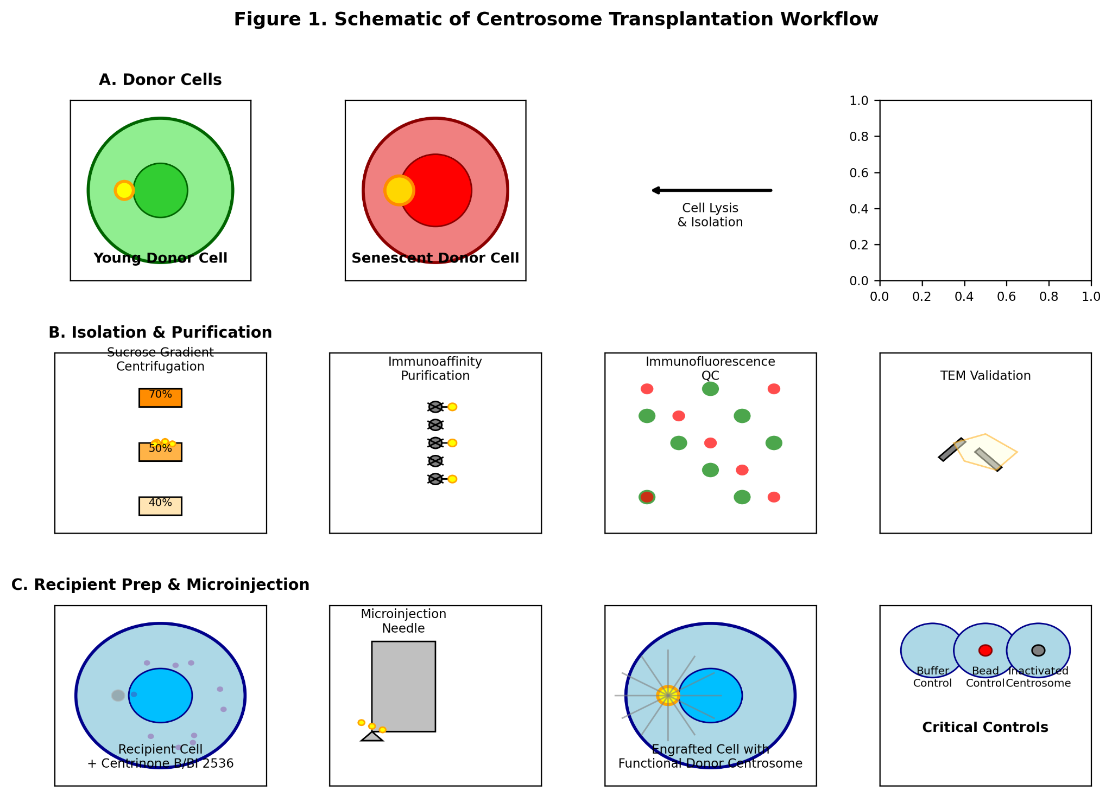
(A) Isolation pipeline from donor cells (young vs. senescent) to purified centrosomes via sucrose gradient and optional immunoaffinity purification.
(B) Quality Control steps: Immunofluorescence for centrin (green) and γ-tubulin (red), and Transmission Electron Microscopy of an isolated centrosome.
(C) Recipient cell preparation via pharmacological centrosome depletion (Centrinone B/BI 2536) followed by microinjection of the isolated organelle.

Figure 2. Multi-Parametric Phenotypic Analysis Post-Transplantation.

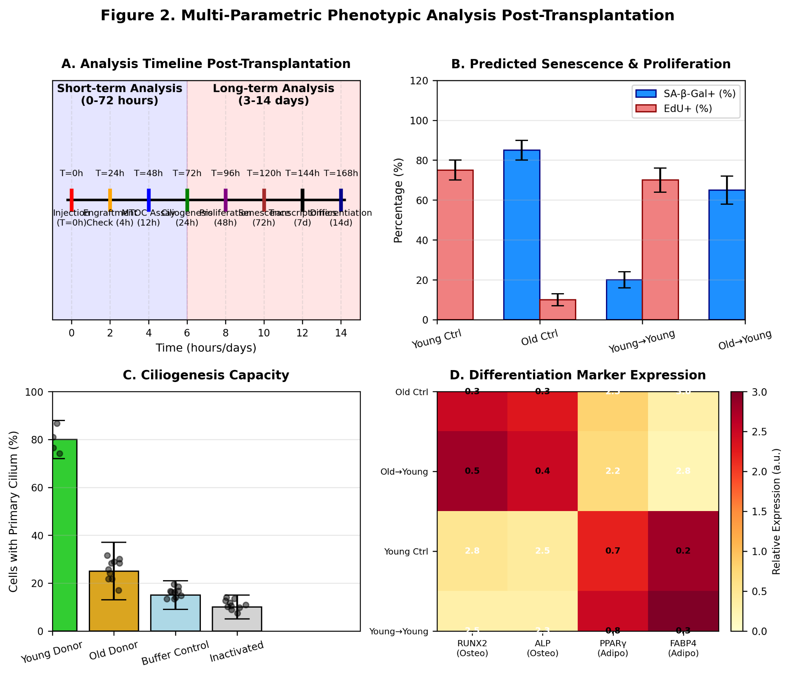
(A) Timeline for short-term (engraftment, MTOC function, ciliogenesis) and long-term (proliferation, senescence, differentiation) assays.
(B) Predicted outcomes: Representative images showing increased SA-β-Gal staining (blue) and decreased EdU incorporation (red) in cells receiving "old" vs. "young" centrosomes.

Figure 3. Theoretical Model and Key Predictions.

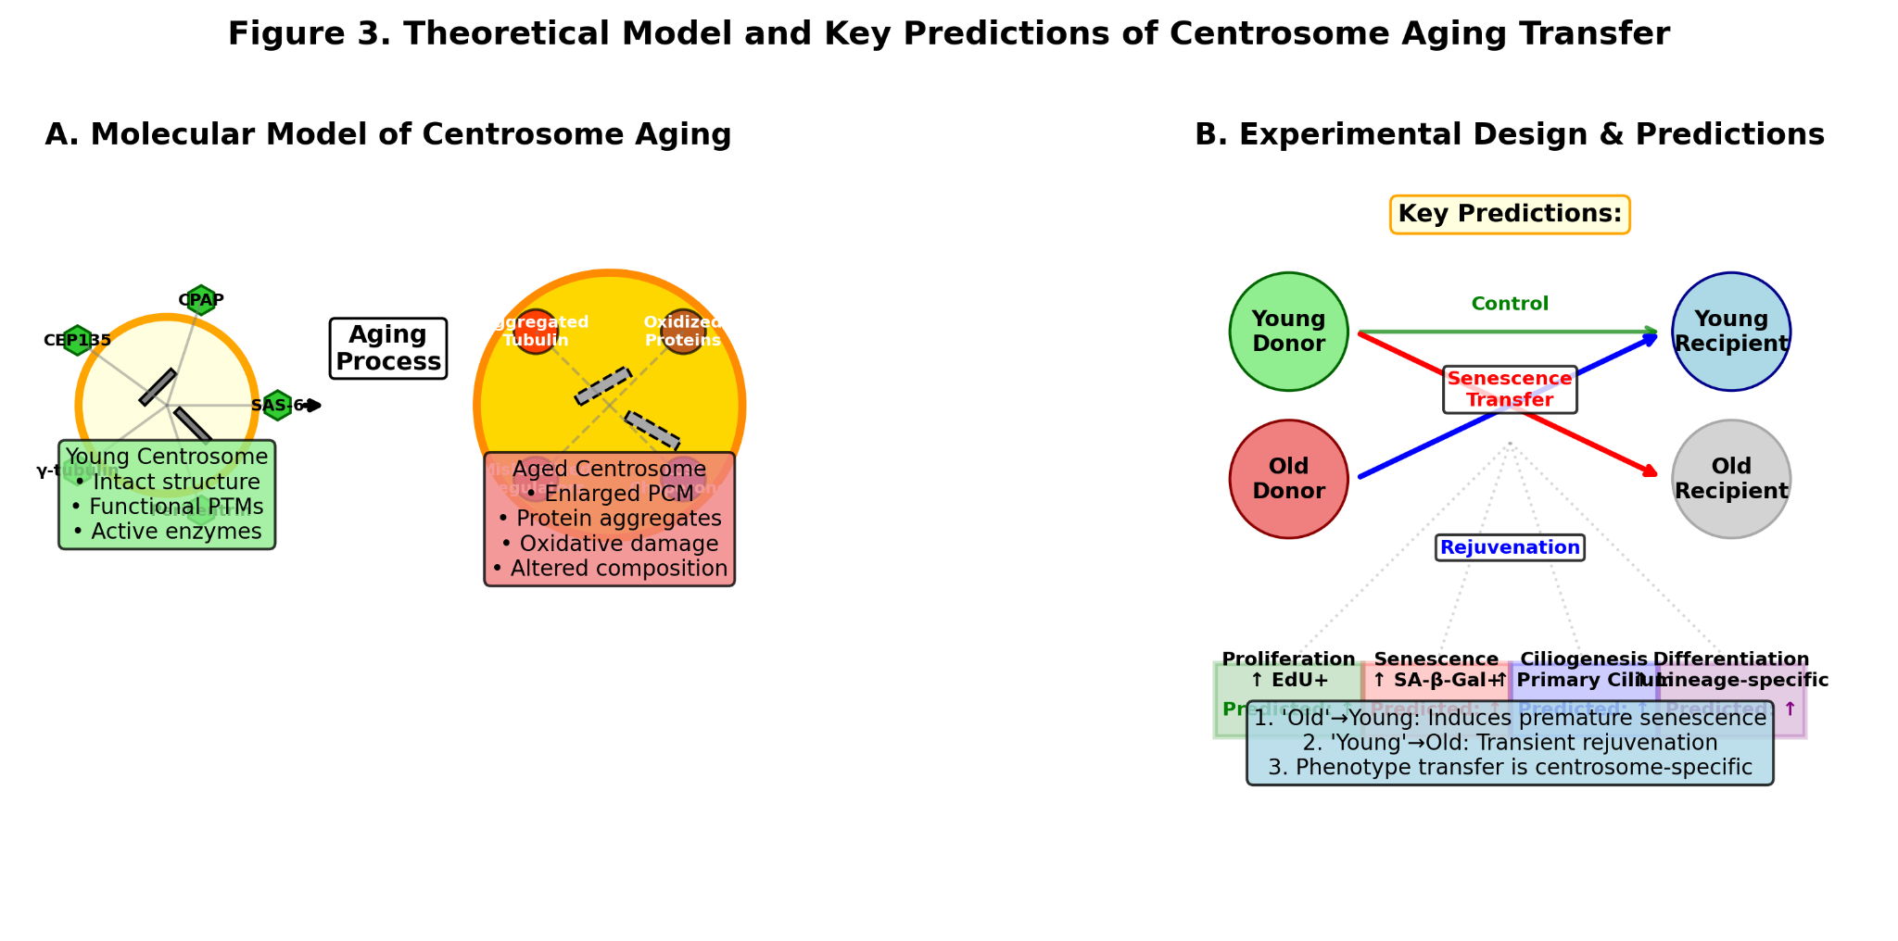
Diagram illustrating the central hypothesis: The "aging state" (protein aggregates, oxidative PTMs, altered composition) of a donor centrosome is sufficient to transfer a senescent phenotype to a young cell, affecting proliferation, ciliogenesis, and differentiation.

